Extra Practice 6
Lesson 3.6: Dividing Fractions

1. Write the reciprocal of each fraction.
a) b) c) 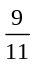 d) 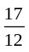

2. Use a copy of each number line to illustrate each quotient.
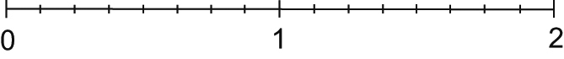
a) 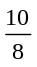 ÷

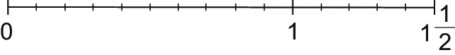
b) 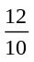 ÷

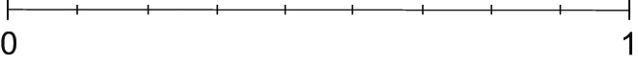
c) ÷

d) 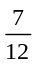 ÷

3. Use multiplication to find each quotient.
a) ÷ b) ÷ c) 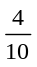 ÷ d) ÷

4. Use common denominators to find each quotient.
a) 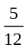 ÷ b) ÷ c) ÷ d) ÷

5. Write three division questions that have as their quotient.

Extra Practice Sample Answers

Extra Practice 6
Lesson 3.6
1. a) b) c) 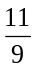 d) 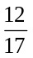
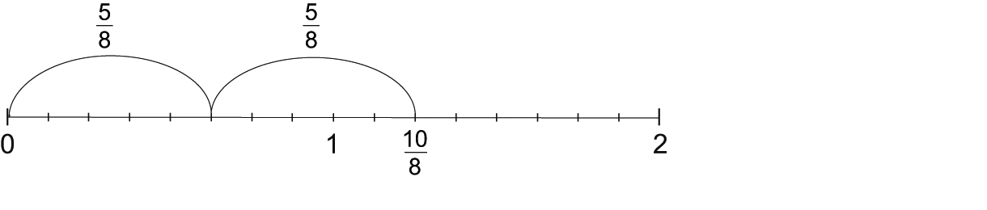
2. a) 2

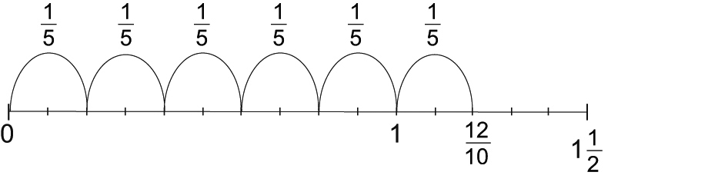
b) 6

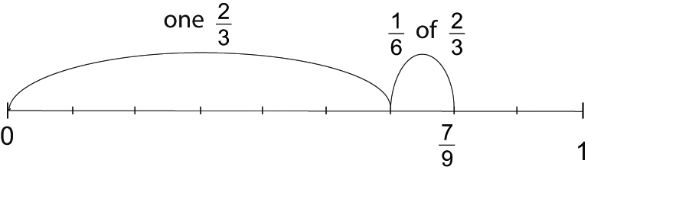

c) 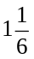

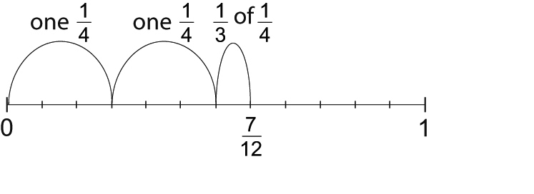
d) 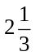

3. a) 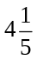 b) 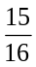 c) 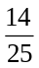 d)
4. a) 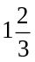 b) 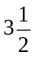 c) 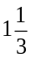 d) 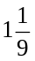
5. a) 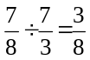 b) 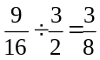 c) 

