Extra Practice 3
Master 8.28
Lesson 8.3: Building Objects from Their Views
1. Use linking cubes to build an object for each set of views below.
a)
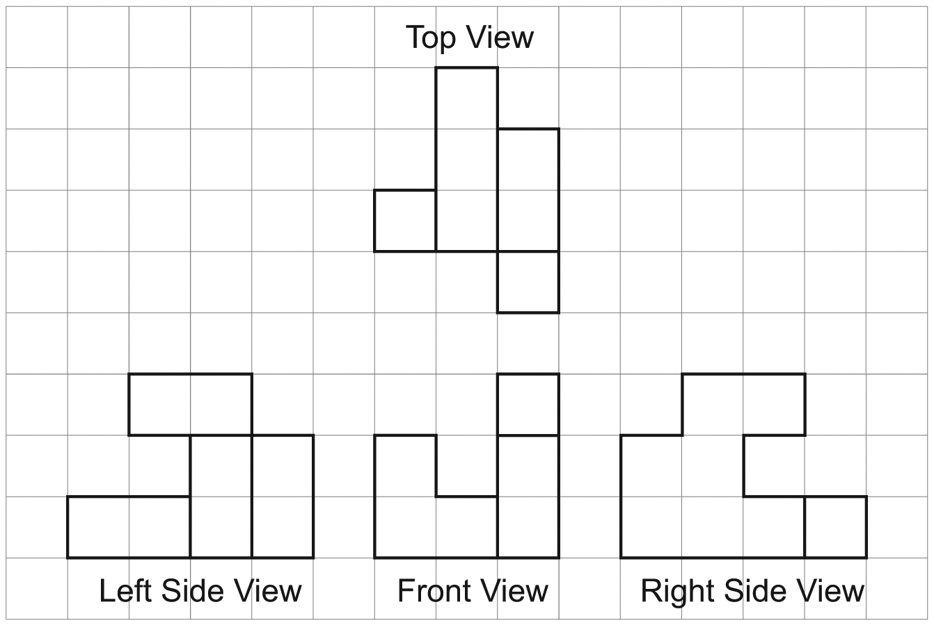

b)
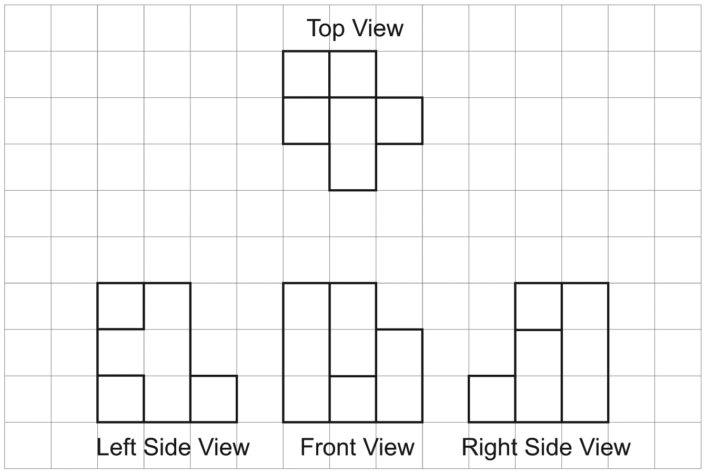

Extra Practice 3 – Master 8.28
Lesson 8.3
1. a)
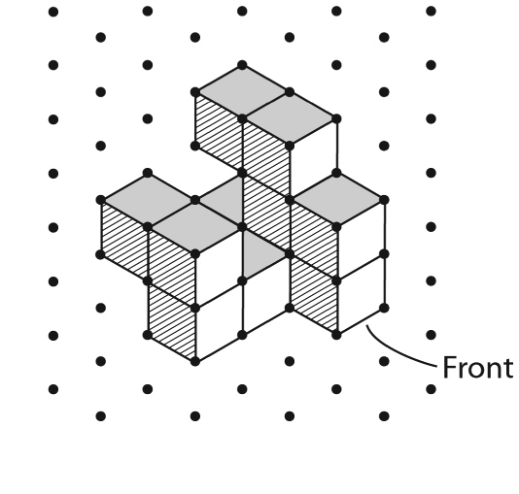
b)


