Extra Practice 2

Lesson 8.2: Drawing Views of Rotated Objects
Master 8.27
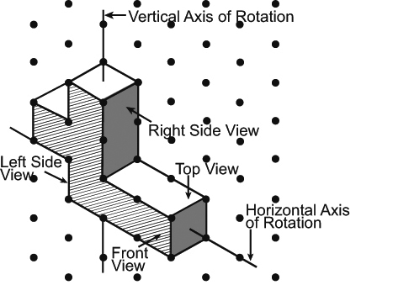
1. Build this object.
Rotate the object as describe below,
then match each view to the front, top,
and side views of the rotated object.
A lettered view can be used more than once.
a) a horizontal rotation of 90° clockwise about
the vertical axis shown
b) a horizontal rotation of 180° clockwise about the vertical axis shown
c) a vertical rotation of 90° away from you about the horizontal axis shown

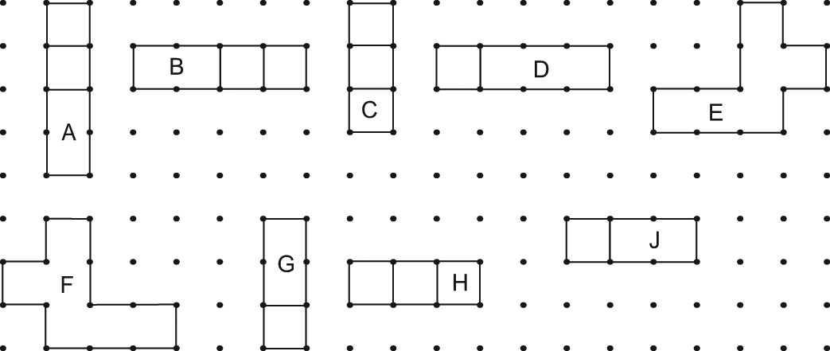

2. Suppose the object in question 1 was rotated horizontally 180° counterclockwise about the vertical axis shown. How would the views of the object after the rotation compare to those in question 1b? Justify your answer.

3. Here is an isometric drawing of an object.
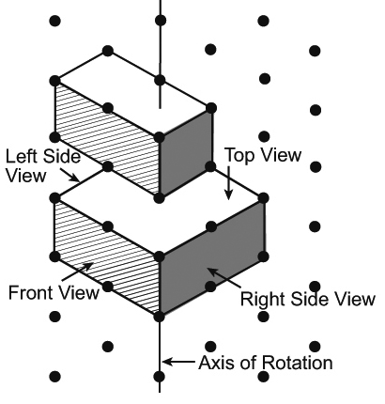

The object is rotated horizontally 270° clockwise about the axis shown.
a) Draw the front, top, and side views of the object after the rotation.
b) Describe a different rotation that will have the same views as the ones you drew in part a.

4. Use the object in question 3.
Suppose the object is rotated 270° counterclockwise.
Will the new views of the object be the same as those drawn in question 3a?
If your answer is yes, explain how you know.
If your answer is no, draw the new views.

Extra Practice 2 – Master 8.27
Lesson 8.2
1. a) Front: G; Top: A;
Left side: F; Right side: E
b) Front: E; Top: B;
Left side: G; Right side: C
c) Front: D; Top: F;
Left side: H; Right side: J
2. The views would be the same because a rotation of 180° clockwise is the same as a rotation of 180° counterclockwise.
3. a)
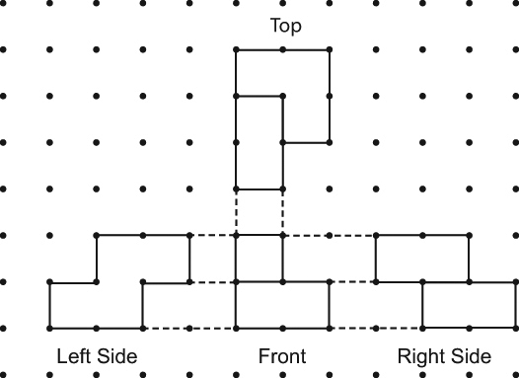
b) A horizontal rotation of 90° counterclockwise about the axis shown
4. No


