Extra Practice 1
Lesson 8.1: Sketching Views of Objects
Master 8.26
1. Sketch the top, front, and side views of each object.
a) | 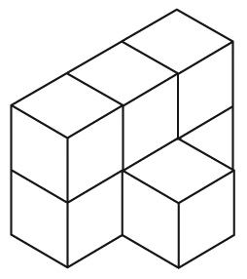 | b) | 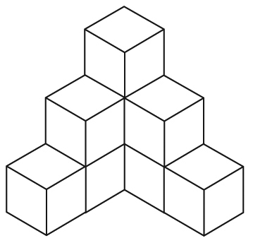 | c) | 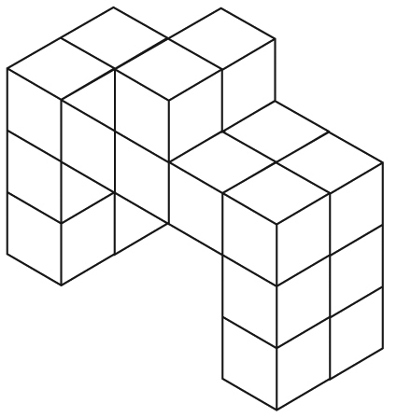

2. Sketch the top, front, and side views of each object drawn on isometric dot paper.
a) b) c)
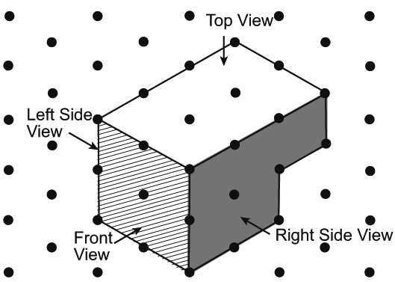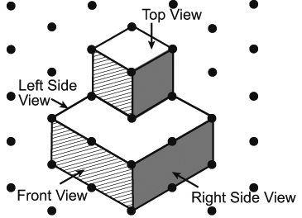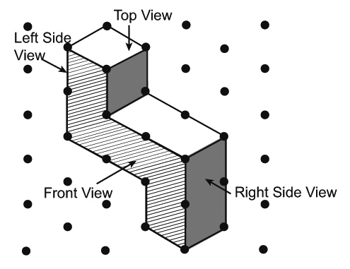

3. Use linking cubes.
Make the letter E.
Sketch the front, top, and side views of your model.

4. Sketch the top, front, and side views of each object at home or in the classroom.
a) a tissue box
b) a CD case
c) a cereal box

Extra Practice 1 – Master 8.26
Lesson 8.1
1. Answers may vary depending on the orientation chosen.
a)
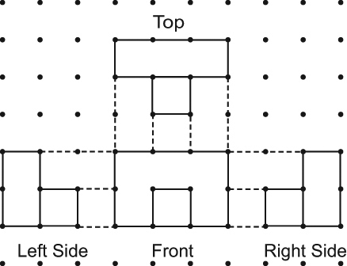
b)
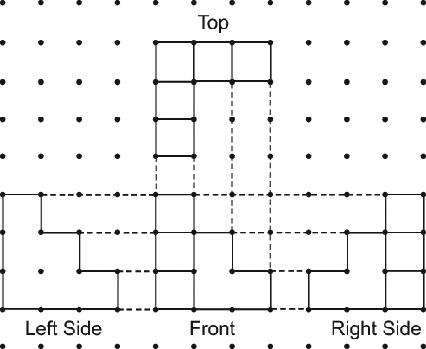
c)
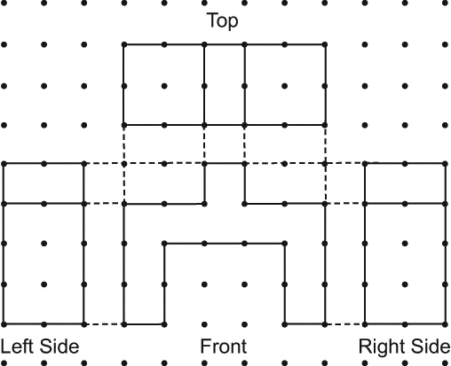
2. a)
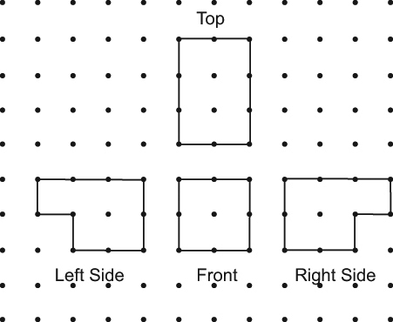
b)
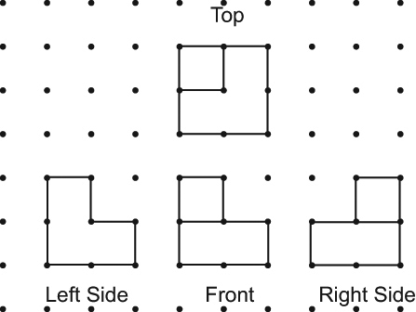
c)
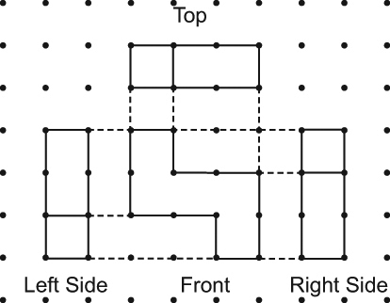
3.
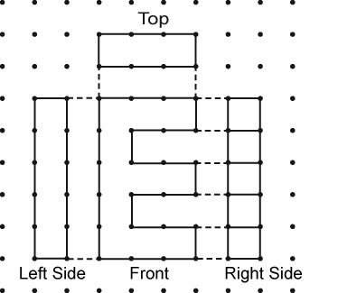
4. a)
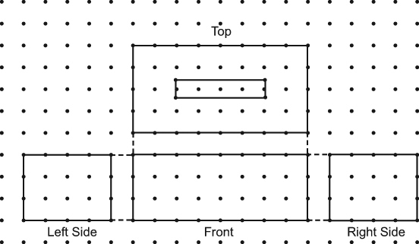
b)
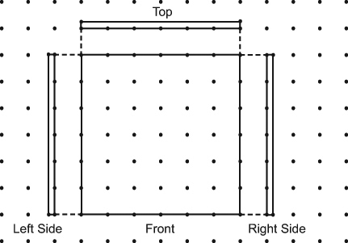
c)


