Extra Practice 1
Lesson 2.1: Using Models to Multiply Integers
1. a) Evaluate.
(–3) + (–3) + (–3) + (–3)
b) Explain why (+4) × (–3) has the same value as the expression in part a.
2. Use coloured tiles to find each product.
a) (+4) × (+3) b) (+6) × (–7)
c) (–5) × (+3) d) (–8) × (–3)
3. Use a number line to find each product.
a) (+8) × (+2) b) (+3) × (–4)
c) (–6) × (+6) d) (–9) × (–2)
4. The ice on Mattias's skating pond melted 2 cm every day for 5 days.
Use integers to find the change in the depth of the ice after 5 days.
5. Aliya climbs down a ladder. The rungs on the ladder are 30 cm apart.
a) Aliya climbs down 2 rungs. Use integers to find her total change in elevation.
b) How much higher was Aliya before she climbed down 3 rungs?

Extra Practice Sample Answers

Extra Practice 1 – Master 2.18
Lesson 2.1
1. a) –12
b) Adding a number 4 times is the same as 4 times the number.
2. a) +12

b) –42
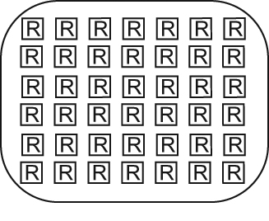
c) –15
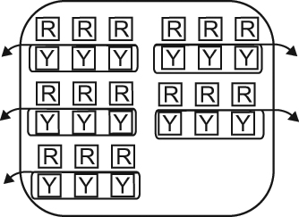

d) +24
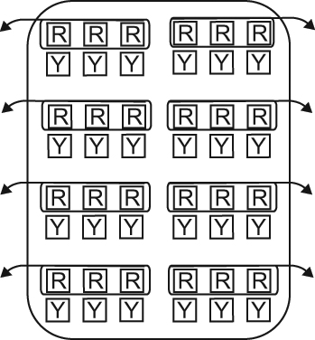

3. a) +16
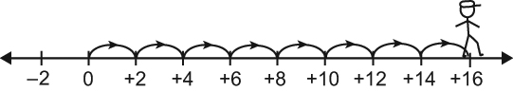

b) –12
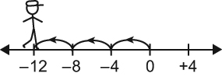

c) –36
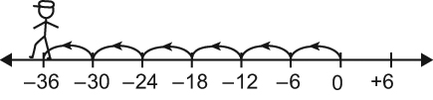

d) +18
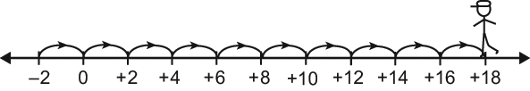
4. (+5) × (–2) = –10; the ice melted 10 cm after 5 days.
5. a) (+2) × (–30) = –60; Aliya is 60 cm below her previous elevation.
b) (–3) × (–30) = 90; Aliya was 90 cm above her current elevation.

