Extra Practice 3
Lesson 1.3: Measuring Line Segments
1. Simplify.
a) 5² b) c) 8² d)
e) 1² f) 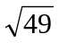 g) 9² h)
2. The area A of a square is given. Find its side length.
Which side lengths are whole numbers?
a) A = 9 cm² b) A = 56 m² c) A = 81 cm²
e) A = 16 m² f) A = 42 cm² g) A = 72 m²
3. Copy each square on grid paper. Find its area.
Then write the side length of the square.
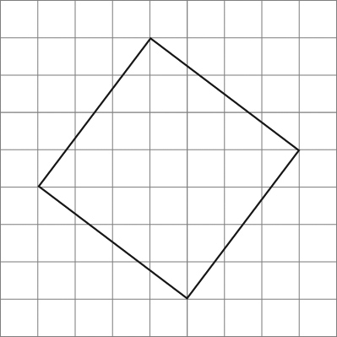
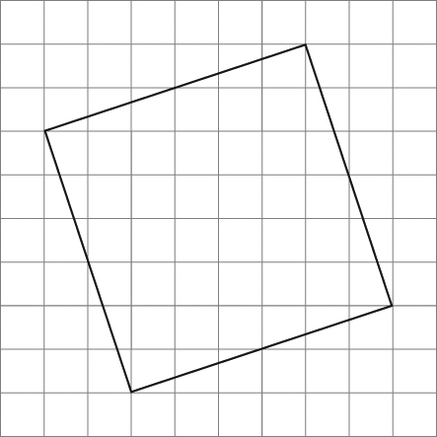
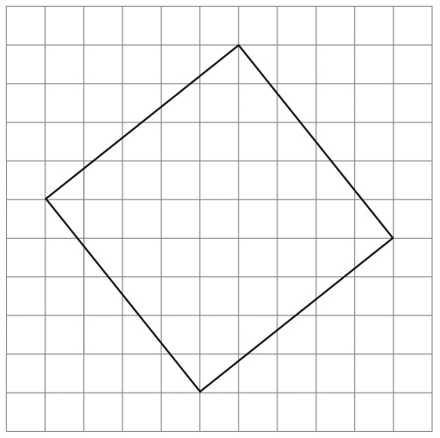
a) b) c)

4. Copy each line segment on grid paper.
Draw a square on each line segment.
Find the area of the square and the length of the line segment.
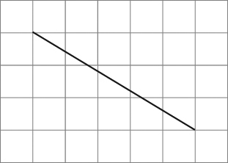
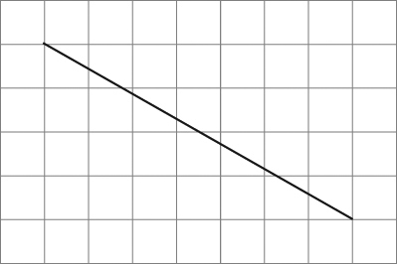
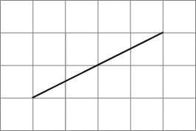
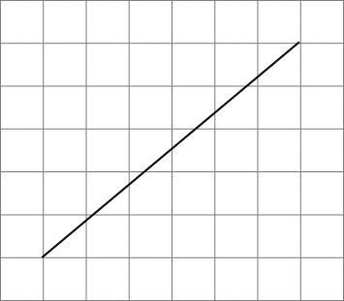
a) b) c) d)

Extra Practice Sample Answers

Extra Practice 3 – Master 1.26
Lesson 1.3
1. a) 25 b) 14
c) 64 d) 15
e) 1 f) 7
g) 81 h) 100
2. a) 3 cm b) 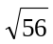 m c) 9 cm
d) 4 m e) 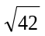 cm f) 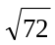 m
The side lengths in parts a, c, and d are
whole numbers.
3. a) 25 square units
b) 40 square units
c) 41 square units
4. a) 34 square units; 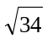 units
b) 65 square units; 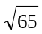 units
c) 20 square units; 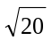 units
d) 61 square units; 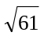 units

